|  |  |  |  |  |
| --- | --- | --- | --- | --- |
| Project: | {Personal Health Monitoring System (PHMS)}  CSE 5325 – Fall 2015  Project Management | | | |
| Module: | Project Cost Estimation | | | |
| Deliverable: | cost Document | | | |
| Version: | | [1.0] | Date: | [10/29/2015] |

Prepared by: {Yerramsetti Sandeep kumar, 1001156902}

TABLE OF CONTENTS:

1.IntrODUCTION AND EXECUTIVE SUMMARY 3

2. PROJECT COST PLANNING 4

2.1 HARDWARE COST 4

2.2 COMPONENT COST 4

2.3 COST ESTIMATION 5

2.3.1 scale drivers 5

2.3.2 cost drivers 6

3. Reports of the cost estimation 9

4. risk analysis 15

5.conclusion 16

6. references 17

# Introduction and Executive Summary

The main objective of this project is to estimate the cost of an android application which will be useful in keeping track of one’s vital signs, daily medicine intake, or following a diet regiment.

The android application will include Registration, Vital signs, Medication, Diet, Electronic storage, secure system, Search, Monitoring system, Communication, Data Maintenance

This project would include 5 developers.

The budget of this project is up to $256,000 including the 100% profit

# 2. Project Cost Planning

2.1 Hard ware cost

Laptops: Dell Inspiron - $500

Quantity – 10

Total Cost - $500 * 10 = $5000

Servers –Windows based server - $2400

Quantity – 2

Total Cost - $2400 * 2 = $4800

Database – MySQL Standard Edition - $1000

Quantity – 1

Total Cost - $1000

Cloud storage – 100*3=300

**Total Cost –** 5000+4800+1000+300 =11,100

2.2 Personal health monitoring system component cost

Internet – TWC high speed internet with 50 Mbps

Cost - $70 per month

Total Cost - $210

Security Software – McAfee - $50

Quantity – 10

Total Cost - $500

Security packages –advance encryption package pro-50

Total cost 500

Microsoft project plan -$25

Quantity - 6

25*3*6= $450

We use the free testing software.

**Total Cost –** 210+500+450 +500= $1760

**2.3 Cocomo software cost estimation:**

* **COCOMO Scale Drivers:**

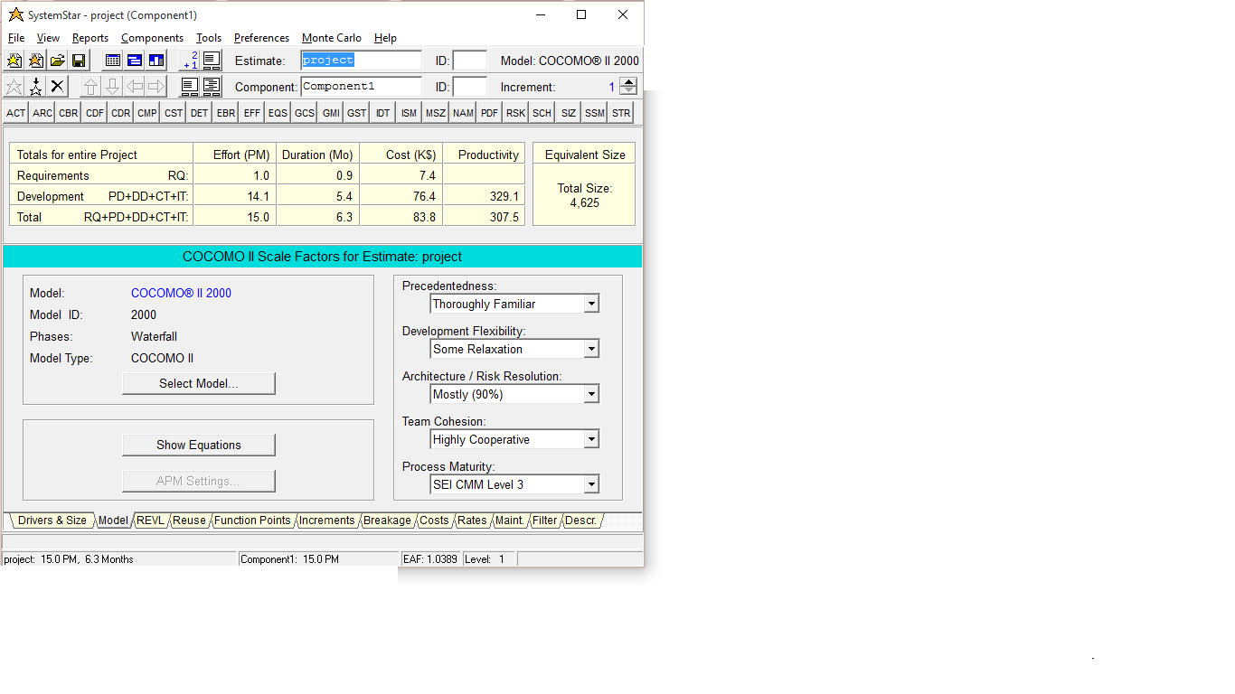

1. **Precedentedness :** Set to thoroughly familiar

The developers have a full understanding of objectives of the product and the developers have a well-known experience in working with the software related systems.

1. **Development Flexibility:** Set to Some Relaxation

The developers must be in order to the pre-established requirements of the project. The project can be completed early.

1. **Architecture / Risk Resolution:** Set to mostly (90%)

Most of the risks are identified by it and a Strong tool support is available resolving risk items, developing and verifying architectural specs.

1. **Team Cohesion:** Set to highly Cooperative

The members in a team are highly helpful to the other members and also the developers can work in a team as they are highly cooperative. Since they are working as a team, the developers try to achieve a shared vision.

1. **Process Maturity:** Set to SEI CMM Level 3

The process in the project is standardized.

* **Cocomo cost drivers:**

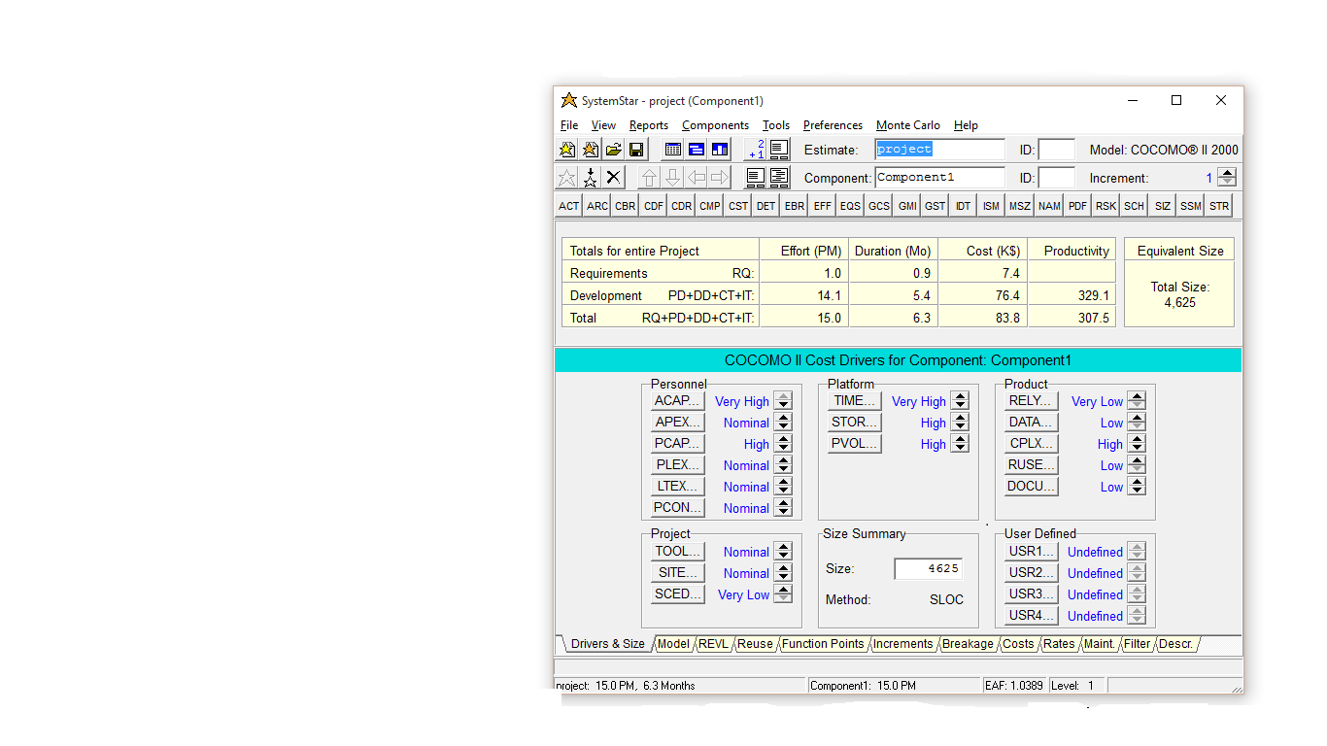

**PERSONNEL:**

1. **Analyst Capability:** Set to Very High.

The developer’s efficiency of developing the code or the UML diagrams is high, as they have an experience in the job, the ability to communicate with the team or with the system is very good, analyzing and the design abilities of the analyst are good.

1. **Applications Experience:** Set to nominal.

The Programmers are experienced with 1 year and have worked on similar kind of project in last year.

1. **Programmer Capability:** Set to High.

The programmer has knowledge of the concepts very well and can also adapt to the requirements of the user and the environment

1. **Platform Experience:** Set to nominal.

The application is mobile based. The programmers have knowledge in the mobile based technologies.

1. **Language and tool experience:** Set to nominal.

The members have an experience of 1 year and have worked on similar project and are familiar with the process and can work easily on this tools so they won’t take much time to adjust to any new updates in the tools.

1. **Personnel Continuity Cost Driver:** Set to nominal.

The rating scale for PCON is set in terms of project’s annual personnel turnover. This is set to 12%/year.

**PROJECT:**

1. **Use of software tools:** Set to Nominal.

The team members use the basic lifecycle tools and the process are moderately integrated.

1. **Multisite Development:** Set to nominal.

The team is present in multi/city or the Multi-company and the communication used is narrowband email.

1. **Development Schedule:** Set to very low.

The development schedule is set low because the developers are involved in a paid vacation so it is set to very low so that it is 75% of the nominal.

**PLATFORM**

1. **Execution time constraint:** Set to very high

We are imposing a time constraint upon the system and using about the 85% of available execution time as we need to keep testing the project

1. **Main Storage constraint:** Set to high

Since our project involves in the storage of the data and the use of the available processor we set this to high and we use about 70% of the available storage.

3. **Platform Volatility:** Set to high.

Platform Volatility is based upon the various changes that a project goes through. Major change in this project is occurred every 2 months as this involves in the keeping up with the new technologies in the world, minor change occurs every 1 week as there are improvements being created to help the project better.

**PRODUCT:**

1. **Required reliability:** Set to Very Low.

The product requires reliability in case of any miss happens so it is set to very low so that the data can easily be recovered in case of any loss of data.

1. **Database Size:** Set to Low.

The data base size is set low because to generate the test data that will be used to exercise the program and it doesn’t require large requirements

1. **Product Complexity:** Set to high.

The application is based upon the health monitoring system and is based upon the monitoring of the body so the code involved in developing the project is complex.

1. **Required Reusability:** Set to Low.

While developing this project we don’t do more elaborate design or the documentation so that we can use it later. We develop only for this project so this is set as low because we don’t reuse later.

1. **Documentation match to documentation needs:** Set to Low.

We set this low because some of the life-cycle needs are not being covered in this project.

**Source Lines of Code:** The project contains 4625 lines of code. The complexity of the project is dependent on the SLOC.

REPORTS:

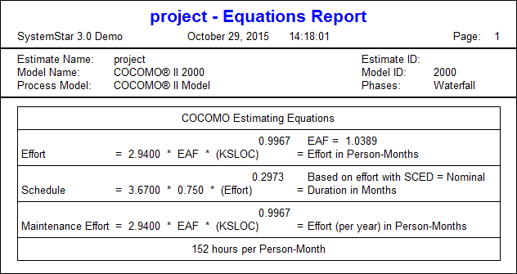

## 2.4 Overhead Cost

The overhead cost is $10000 which is 25%.

Cost of the resources and managers:

The cost of the developers is 5*5000*3 =75000

The cost of the manager is 1*10000*3= 30000

## 2.5 Total Cost

11100 +1760+10000+75000+30000= 127,860

NOTE: Decrease in the cost is because of the decrease in the cost of the laptop and few other needs even though we have added project plan costs and the cloud storage costs.

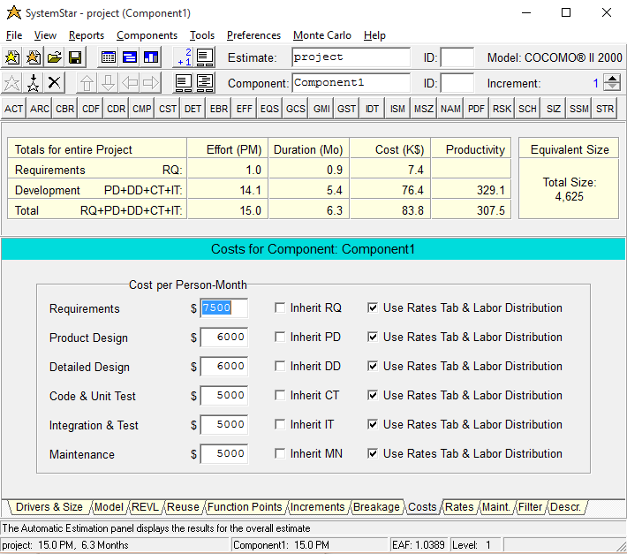

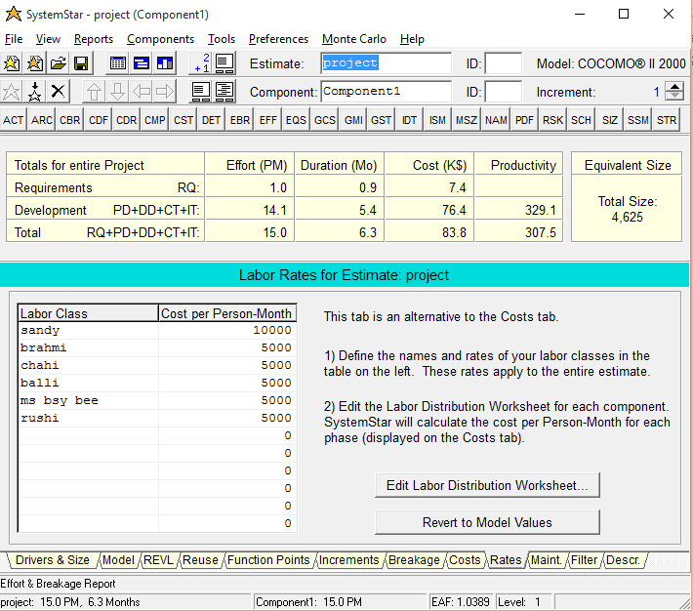

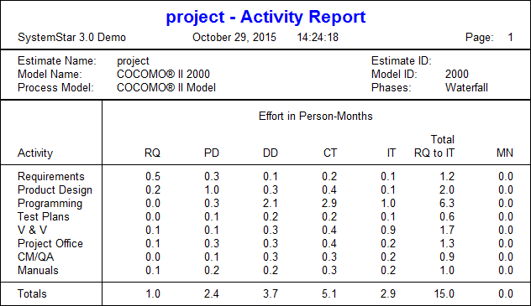

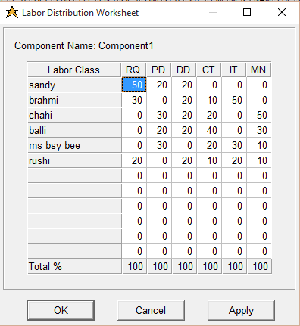

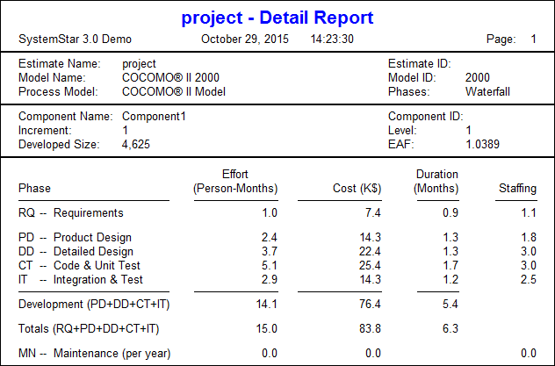

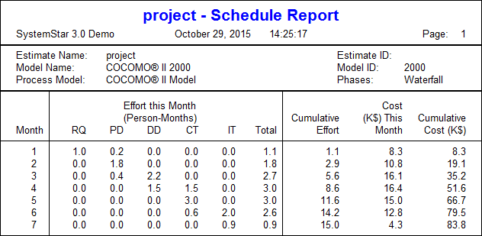

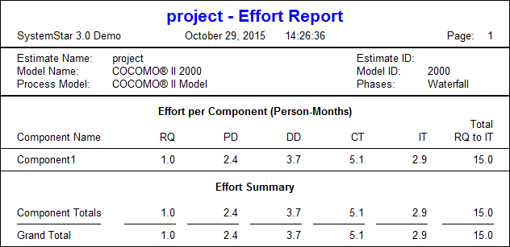

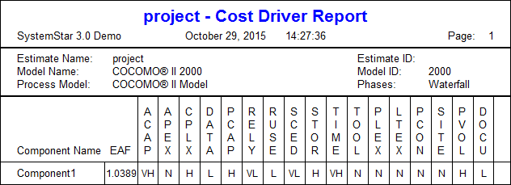

Risks:

1. Since the schedule is set to 75% of the nominal the project might get delayed if any unexpected conditions turn up.
2. Since the complexity is high, it takes time for the developer to develop the product efficiently.
3. Unexpected health conditions of the employees may arise during the course of the development application for which backup of the employees are needed
4. Since the application and the platform experience is nominal, the process might get slower
5. Since the project is done multi city or Multi Company, the communication might be hindrance.

Risk mitigation:

1. Meetings should be frequent throughout the course of the projects and meetings before the deadline of the submission assignment.
2. Going thorough any similar projects under development or which are developed

**Conclusion:**

The application of personal health monitoring system is developed with 5 developers.

The cost of the project is 256,000. The cost is proportionally distributed throughout all the phases of the project and the also calculated the profit.

There are a few risks involved with the project which can be mitigated by meeting and reference of previous projects.

I recommend providing a backup for the developers

* **References:**

<http://www.softstarsystems.com/>

<http://sunset.usc.edu/research/COCOMOII/expert_cocomo/drivers.html>

<http://www.zdnet.com/article/cloud-storage-price-check/>

<http://www.ebay.com/itm/like/351478747595?ul_noapp=true&chn=ps&lpid=82>

<http://www.timewarnercable.com/en/plans-packages/internet/internet-service-plans.html>

<http://encryption-software-review.toptenreviews.com/>